1. Create the following table and enter at least 5 records in each.

create table manager(

managerid number(10) primary key,

fname varchar(30),

mname varchar(30),

lname varchar(20),

address varchar(30),

city varchar(40),

department varchar(40) check(department in('account','sales','marketing')),

gender char(1) check(gender in ('m','f')),

mobile_number number(10)

);

insert into manager values(11,'joker','gotam','city','hevan','swarg','account','m',9292929292);

insert into manager values(12,'harly','gotam','city','hell','nark','account','f',9000000000);

insert into manager values(13,'prince','dipakbhai','hirapara','hevan','swarg','account','m',9898989898);

insert into manager values(14,'norra','tridev','fatehi','hell','nark','sales','f',6969696969);

insert into manager values(15,'sunny','chote','leon','mumbai','bombey','marketing','f',6969686969);

create table employ(

managerid number(10) references manager(managerid),

employid number(20),

employee_name varchar(20),

department varchar(40)

);

insert into employ values(11,0011,'joker','account');

insert into employ values(12,0012,'harly','account');

insert into employ values(13,0013,'prince','account');

insert into employ values(14,0014,'noora','sales');

insert into employ values(15,0015,'sunny','marketing');

2)

declare

v_managerid manager.managerid %type;

v_fname manager.fname%type;

v_mname manager.mname%type;

v_lname manager.lname%type;

v_address manager.address%type;

v_city manager.city%type;

v_department manager.department%type;

v_gender manager.gender %type;

v_mobileno manager.mobile_number%type;

begin

v_managerid := :managerid;

v_fname:= :fname;

v_mname:= :mname;

v_lname:= :lname;

v_address:= :address;

v_city:= :city;

v_department:= :department;

v_gender:= :gender;

v_mobileno:= :mobileno;

insert into Manager values(v_managerid ,v_fname,v_mname,v_lname,v_address,v_city,v_department,v_gender,v_mobileno);

dbms_output.put_line('data inserted');

end;

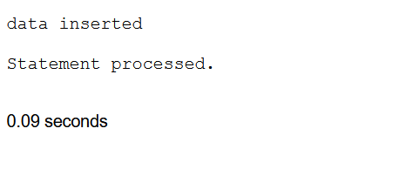

3.

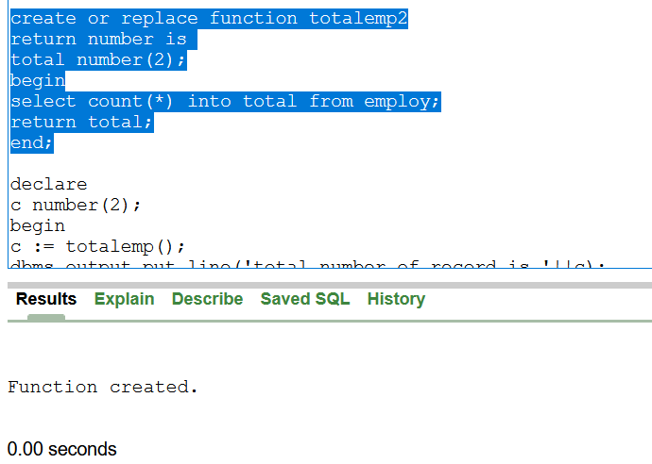

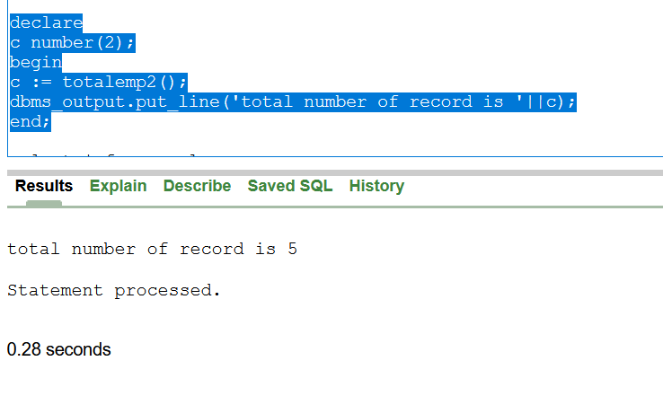

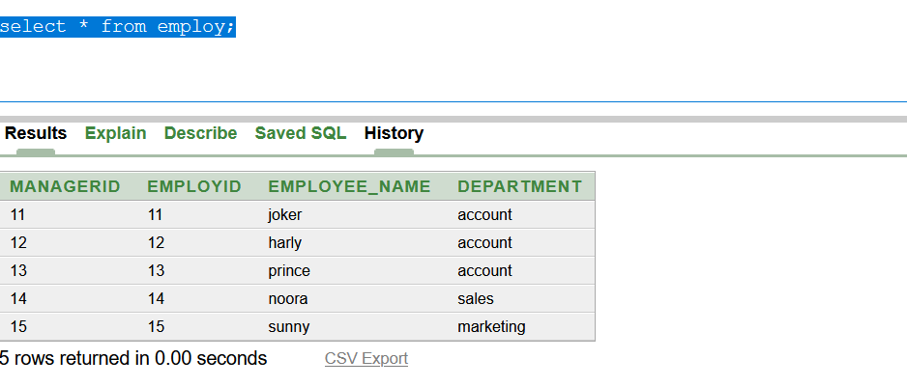

2. Create a trigger which is executed on updatingemployeeidand employeenameinEmployeetable and the old row of data will be copied in backup table.

